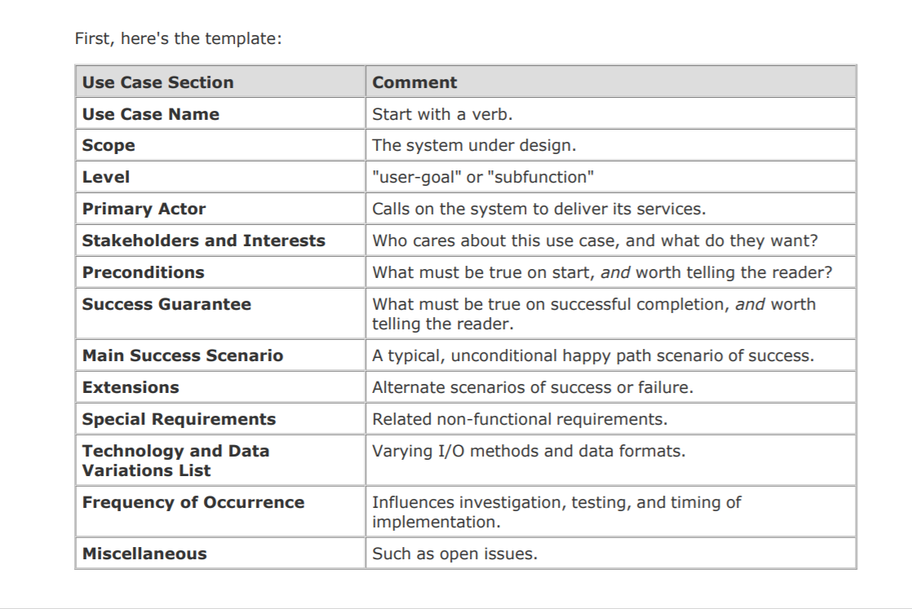

**Use case 4: Brugeren starter spillet**

**Scope:**

Game Application

**Level:**

**Stakeholders and interests:**

User goal: wants to start playing the game

Developer: wants the game map and objects to get started and proceed to game mechanics

Company: wants to keep the user invested in the game

**Primary Actor:**

User

**Preconditions:**

Use case 5: Brugeren logger på

**Main Success scenario:**

System creates a 10x10 coordinate map

Creates rabbit & snake

Randomly assigns them to separate locations

Outputs snake & rabbit location to user

**Extensions:**

Game does not start and an error message is displayed

**Special requirements:**

None

_________________________________________________________________________

**Use case 5:** Brugeren logger ind

**Scope:**

Game Application

**Level:**

**Stakeholders and interests:**

User goal: Wants to log in, in order to save high scores

Developers: Wants feedback and create user retention

**Primary Actor:**

User

**Main Success scenario:**

The user logs in successfully and plays the game

**Alternate scenario (Extensions):**

The user logon is denied

**Special requirements:**

Login

_________________________________________________________________________

**Use case 6:** Main menu

**Scope:**

Control information and game input options

**Level:**

**Stakeholders and interests:**

User: Wants to enter the game

Developers: Want the menu to function and allow customizability of the game

**Primary Actor:**

User - Customizes the game

**Main Success scenario:**

User enters the menu and customizes the game successfully

**Alternate scenario (Extensions):**

Menu does not appear and is not allowed to customize and start the game

**Special requirements:**

_________________________________________________________________________

**Use case 10:** Brugeren rykker

**Scope:**

Game progress by movement

**Level:**

**Stakeholders and interests:**

User: wants to move the character and win the game

**Primary Actor:**

The user

**Main Success scenario:**

The user successfully moves his character

**Alternate scenario (Extension):**

Wrong input, move is not registered

**Special requirements:**

_________________________________________________________________________

**Use case 12:** Kommer de ind for 1 felt af hinanden aktiveres scenarie

**Scope:**

Character warning

**Level:**

**Stakeholders and interests:**

User: wants to survive and keep playing

**Primary Actor:**

User

**Main Success scenario:**

User comes within a single move from the snake and the mercy begging is triggered

**Alternate scenario (Extension):**

User comes within a single move from the snake and the mercy begging is not triggered

**Special requirements:**

_________________________________________________________________________

**Use case 21:** Slangens responds

**Scope:**

Continues or ends game

**Level:**

**Stakeholders and interests:**

User: Wants to survive and proceed the game

Developers: Wants the user to keep playing

**Primary Actor:**

User

**Main Success scenario:**

The snake responds accordingly to user input which ends or continues the game

**Alternate scenario (Extension):**

Game crashes

**Special requirements:**

_________________________________________________________________________

**Use case 22:** Spillet slutter og returnerer brugeren til menuen

**Scope:**

The game ends and the user returns the menu

**Level:**

**Stakeholders and interests:**

User: has the opportunity to restart the game

Developers: Wants the user to keep playing

**Primary Actor:**

User

**Main Success scenario:**

The user finishes the game and arrives to the menu

**Alternate scenario (Extensions):**

The user quits

**Special requirements:**

_________________________________________________________________________

**Use case 19:** Brugeren kan registrere sin score

**Scope:**

Different players can display their scores

**Level:**

**Stakeholders and interests:**

User: Wants to display their score

Developers: Wants players to partake in leaderboards

**Primary Actor:**

User

**Main Success scenario:**

The user successfully registers his/her score

**Precondition:**

Usecase 5: Brugeren logger ind

**Alternate scenario:**

The user dosent registere their scores

**Special requirements:**

Need ability to store scores